Data Analytics Mini Project Documentation
Project Title | A Data-Driven Framework for Student Success and Employability Analytics
Dataset Name | Edu Pulse: Student Academic and Career Analytics Dataset
Tools & Technologies | Microsoft Excel, Power Query, Microsoft Power BI Desktop & DAX

Problem Statement & Executive Summary
Educational institutions often maintain student information across multiple fragmented systems, including academic records, attendance tracking, extracurricular participation, and placement management. Due to manual data entry, disconnected databases, and inconsistent data standards, raw datasets frequently exhibit missing values, duplicate records, invalid entries, and conflicting representations. These data quality issues impede accurate reporting and strategic decision-making regarding student performance, institutional retention, and graduate employability.
This project cleans, normalizes, integrates, and analyzes student records across the institution using Excel, Power Query, and Power BI. By consolidating raw tables into a validated analytical data model, the project surfaces actionable insights across attendance behavior, academic progression, extracurricular involvement, and placement readiness to enable evidence-based institutional governance.
Primary & Business Objectives
Primary Objective
To perform end-to-end data quality assessment, data cleansing, and interactive dashboard development on a higher education dataset to identify factors influencing student academic performance, engagement, and placement outcomes.
Business Objectives
- Improve Data Quality: Resolve data inconsistencies, handle missing values, and standardize attributes across source tables.
- Analyze Attendance & Academics: Examine the empirical relationship between attendance trends and final academic outcomes.
- Measure Engagement Impact: Quantify the influence of club participation and extracurricular engagement on student performance.
- Evaluate Employability Readiness: Track placement conversion rates, compensation packages, and domain-specific recruitment trends.
- Develop Interactive Dashboards: Build executive-ready Power BI dashboards to support continuous institutional decision-making.
- Monitor Student Success Metrics: Provide real-time visibility into high-risk attendance profiles, academic clearance rates, and placement benchmarks.
Scope of Analysis
- Student Demographics: Geographic origin, department quotas, family income, and admission classifications.
- Attendance Trends: Working days, present session ratios, and high-risk cohort isolation.
- Academic Performance: Semester marks, course clearance, CGPA progression, and grading distribution.
- Student Engagement Activities: Club enrollment patterns and event category representation.
- Career Readiness Metrics: Internship domain alignment and candidate placement eligibility.
- Placement Performance: Recruiter engagement, corporate offer conversion, and CTC compensation tiers.
1. Dataset Details, Data Quality Issues & Data Cleaning
The institutional dataset encompasses records across academic, demographic, attendance, engagement, and recruitment domains. The table below outlines the attributes, data types, business descriptions, observed quality issues, and the data cleaning transformations applied:
Field Name | Data Type | Description | Data Issue | Cleansing Method / Formula
Student_ID | Text / Varchar | Unique institutional student registration identifier | None (Distinct primary key) | Validated uniqueness across records
City | Text / Varchar | Student native origin / home municipality | Missing and blank location entries | =IF(ISBLANK(E2), "Unknown", E2)
Department | Text / Varchar | Academic branch/major (CIVIL, CSE, EEE, ECE, IT, MECH, MBA) | Inconsistent casing across records | =UPPER(F2)
Family_Income | Decimal / Currency | Annual household financial income (INR) | Null and blank income entries | =MEDIAN(I2:I1001)  =IF(ISBLANK(I2), $L$2, I2)
Gender | Text / Varchar | Demographic gender classification (Male, Female) | None | Standardized categorical formatting
Admission_Type | Text / Varchar | Enrollment entry stream (Merit, Management) | None | Categorical validation
Working_Days | Whole Number (Integer) | Total scheduled institutional instructional days | None | Numeric type casting
Present_Days | Whole Number (Integer) | Total attended lecture sessions per student | Missing daily attendance logs | =AVERAGE(D2:D4657) / AVERAGE(C2:C4657)  =IF(ISBLANK(D2), ROUND(C2 * $F$1, 0), D2)
Semester | Whole Number (Integer) | Academic term index (Semester 1 to 8) | None | Integer ordering
Total_Marks | Decimal / Float | Consolidated assessment score per term (0 - 100) | None | Numeric validation
Practical_Marks | Decimal / Float | Laboratory and practical evaluation score | Missing practical assessment entries | =IF(ISBLANK(E2), G2 - F2, E2)
Club_Name | Text / Varchar | Extracurricular organization name | Missing records for non-members | Mapped to "General / None"
Event_Category | Text / Varchar | Domain of activity (Technical, Sports, Service) | Inconsistent domain classifications | Standardized domain taxonomy
Participation_Type | Text / Varchar | Role level in student activities | Blank participation entries | =IF(ISBLANK(E2), INDEX(E$2:E$6938, MODE(MATCH(E$2:E$6938, E$2:E$6938, 0))), E2)
Placement_Status | Text / Varchar | Recruitment outcome (Placed, Not Placed, Not Eligible) | Inconsistent status tags | Validated institutional categories
Company_Name | Text / Varchar | Hiring enterprise organization | Missing recruiter values for students | =IF(I2="Placed", IF(ISBLANK(J2), "Unknown", J2), "Not Applicable")
Package_LPA | Decimal (Currency) | Annual Cost-to-Company compensation package (LPA) | Ambiguous package values for unplaced cohort | =IF(OR(I2="Not Eligible", I2="Not Placed"), 0, K2)
Internship_Domain | Text / Varchar | Industry internship domain (Software, Data Analytics, Core, etc.) | Leading/trailing whitespace | Text trim and proper case standardization
2. Data Model Architecture
The semantic data model is deployed as an optimized Star Schema with Student_Master functioning as the central dimension, linked to transactional fact tables via 1-to-many (1:*) single-directional relationships on Student_ID:
- Student_Master (1) to Academic_Performance (*) on Student_ID
- Student_Master (1) to Attendance_Summary (*) on Student_ID
- Student_Master (1) to Career_Readiness (*) on Student_ID
- Student_Master (1) to Student_Engagement (*) on Student_ID
3. Calculated Columns & Institutional Business Rules
CGPA (Student_Master)
Averages the student's Total_Marks across all semesters strictly prior to their highest (latest) semester and divides by 10:
CGPA =
VAR CurrentStudent = 'Student_Master'[Student_ID]
-- Find the student's highest (latest) semester
VAR MaxSem =
CALCULATE(
MAX('Academic_Performance'[Semester]),
'Academic_Performance'[Student_ID] = CurrentStudent
)
-- Average their Total_Marks for all semesters strictly less than that max semester
RETURN
DIVIDE(
CALCULATE(
AVERAGE('Academic_Performance'[Total_Marks]),
'Academic_Performance'[Student_ID] = CurrentStudent,
'Academic_Performance'[Semester] < MaxSem
),
10
)
Scholarship_Status (Student_Master)
Evaluates eligibility based on merit (CGPA) and financial criteria (Family_Income):
Scholarship_Status =
VAR PriorCGPA = 'Student_Master'[CGPA]
VAR FamilyIncome = 'Student_Master'[Family_Income]
RETURN
IF(ISBLANK(PriorCGPA) || ISBLANK(FamilyIncome),
"Data Incomplete",
IF(PriorCGPA >= 9,
"Yes",
IF(PriorCGPA >= 7.5 && FamilyIncome <= 1200000,
"Yes",
IF(PriorCGPA >= 6.5 && FamilyIncome <= 1000000,
"Yes",
IF(PriorCGPA >= 5 && FamilyIncome <= 500000,
"Yes",
"No"
)
)
)
)
)
Attendance_Percentage (Attendance_Summary)
Attendance_Percentage =
DIVIDE(
'Attendance_Summary'[Present_Days],
'Attendance_Summary'[Working_Days]
) * 100
Attendance_Status (Attendance_Summary)
Attendance_Status =
VAR AttPct = 'Attendance_Summary'[Attendance_Percentage]
RETURN
IF(
ISBLANK(AttPct),
"Data Incomplete",
IF(
AttPct >= 85,
"Good",
IF(
AttPct >= 70,
"Average",
"Poor"
)
)
)
Grade (Academic_Performance)
Grade =
VAR Marks = 'Academic_Performance'[Total_Marks]
RETURN
IF(
ISBLANK(Marks), "N/A",
SWITCH(
TRUE(),
Marks >= 90, "A+",
Marks >= 80, "A",
Marks >= 70, "B+",
Marks >= 60, "B",
Marks >= 50, "C",
Marks >= 40, "D",
"F"
)
)
Result (Academic_Performance)
Result =
VAR Marks = 'Academic_Performance'[Total_Marks]
RETURN
IF(
ISBLANK(Marks),
"Data Incomplete",
IF(
Marks >= 40,
"Pass",
"Fail"
)
)
Consolidated_Attendance_Summary (Student_Master)
Identifies the most frequent attendance category across a student's records:
Consolidated_Attendance_Summary =
VAR StudentAttendanceRows = RELATEDTABLE(Attendance_Summary)
RETURN
IF(
ISEMPTY(StudentAttendanceRows),
"No Record",
MAXX(
TOPN(
1,
SUMMARIZE(
StudentAttendanceRows,
Attendance_Summary[Attendance_Status],
"StatusCount", COUNT(Attendance_Summary[Attendance_Status])
),
[StatusCount],
DESC
),
Attendance_Summary[Attendance_Status]
)
)
Consolidated_Result (Student_Master)
Consolidated_Result =
VAR StudentAcademicRows = RELATEDTABLE(Academic_Performance)
VAR FailCount =
CALCULATE(
COUNTROWS(Academic_Performance),
Academic_Performance[Result] = "Fail"
)
RETURN
IF(
ISEMPTY(StudentAcademicRows),
"No Record",
IF(
NOT(ISBLANK(FailCount)) && FailCount > 0,
"Fail",
"Pass"
)
)
4. DAX Measure Catalog (KPIs & Metrics)
Total_Eligible_Students
Total_Eligible_Students =
VAR PlacedCount = CALCULATE(COUNTROWS(Career_Readiness), Career_Readiness[Placement_Status] = "Placed")
VAR NotPlacedCount = CALCULATE(COUNTROWS(Career_Readiness), Career_Readiness[Placement_Status] = "Not Placed")
RETURN
COALESCE(PlacedCount, 0) + COALESCE(NotPlacedCount, 0)
Total_Placed_Students
Total_Placed_Students =
CALCULATE(
COUNTROWS(Career_Readiness),
Career_Readiness[Placement_Status] = "Placed"
)
Placement_Rate
Placement_Rate =
VAR PlacedCount = [Total_Placed_Students]
VAR TotalEligible = [Total_Eligible_Students]
RETURN
DIVIDE(
COALESCE(PlacedCount, 0),
TotalEligible,
0
)
Placement_Count
Placement_Count =
FORMAT([Total_Placed_Students], "#,##0") & " Placed / " & FORMAT([Total_Eligible_Students], "#,##0") & " Eligible"
Average_Package_LPA
Average_Package_LPA =
CALCULATE(
AVERAGE(Career_Readiness[Package_LPA]),
KEEPFILTERS(
Career_Readiness[company_name] <> "Unknown"
&& Career_Readiness[company_name] <> "Not Applicable"
)
)
Highest_Package_LPA
Highest_Package_LPA =
CALCULATE(
MAX(Career_Readiness[Package_LPA]),
KEEPFILTERS(
Career_Readiness[company_name] <> "Unknown"
&& Career_Readiness[company_name] <> "Not Applicable"
)
)
Scholarship_Students
Scholarship_Students =
CALCULATE(
COUNTROWS(Student_Master),
TRIM(UPPER(Student_Master[Scholarship_Status])) = "YES"
|| Student_Master[Scholarship_Status] = "1"
)
5. Visualizations, Charts, KPI Cards & Slicers Details
A. Visual Analytics & Charts Specification
Visual Title | Chart Type | Metrics & Fields Used
Student Distribution By City | Map | Location: City | Bubble size: Student_ID
Scholarship Recipient Breakdown | Donut Chart | Legend: Scholarship_Status | Values: Student_ID
Student Admission Category | Pie Chart | Legend: Admission_Type | Values: Student_ID
Student Performance By Department | Clustered Column Chart | X-axis: Department | Y-axis: CGPA
Student Gender Distribution By Department | Clustered Bar Chart | Y-axis: Department | X-axis: Student_ID | Legend: Gender
Student Attendance Summary By Department | 100% Stacked Column Chart | X-axis: Department | Y-axis: Student_ID | Legend: Consolidated_Attendance_Summary
Student Club Participation Analysis | Treemap | Category: Club_Name | Details: Event_Category | Values: Student_ID
Campus Placement Achievement | Gauge | Value: Placement_Rate
Company-Wise Placement & Package Summary | Matrix | Rows: Company_Name | Values: Average_Package_LPA, Maximum_Package_LPA, Student_ID
Internship Domain vs. Placement Outcome | Clustered Column Chart | X-axis: Internship_Domain | Y-axis: Student_ID | Legend: Placement_Status
B. Executive KPI Card Visuals
The top header cards summarize institutional health across key milestones:
- Total Number of Students: Card Visual | Fields: Student_ID
- Scholarship Holders: Card Visual | Fields: Scholarship_Students
- Academic Success Rate: Card Visual | Fields: Consolidated_Result
- Career Placement Achievement: Card Visual | Fields: Placement_Rate
- Average Salary Package: Card Visual | Fields: Average_Package_LPA
- Highest Salary Package: Card Visual | Fields: Highest_Package_LPA
C. Interactive Global Slicers
Global slicer components mounted on the dashboard header strips enable coordinated cross-filtering across all visuals:
- Department (Filter By Department): Slicer Dropdown | Field: Department (Filters by academic division: CIVIL, CSE, EEE, ECE, IT, MECH, MBA)
- Year of Study (Filter By Academic Year): Slicer Dropdown | Field: Year_of_Study (Filters by cohort academic progression year)
- Scholarship Status (Filter By Scholarship Status): Slicer Dropdown | Field: Scholarship_Status (Filters by financial concession qualification: Yes, No)
6. Dashboard Details
The institutional Business Intelligence solution is partitioned into two specialized, synchronized executive dashboards. Both dashboards incorporate global top-strip slicers enabling unified cross-filtering across Department, Academic Year, and Scholarship Status.
Dashboard 1: Edu Pulse: Student Demographics & Academic Performance
This dashboard provides holistic visibility into institutional enrollment, demographic diversity, admission pipelines, merit scholarship distribution, departmental academic excellence (CGPA), and attendance risk categories.
- Top Slicers: Department (Filter By Department), Year of Study (Filter By Academic Year), Scholarship Status (Filter By Scholarship Status).
- Executive KPI Cards: Total Number of Students (1,000), Scholarship Holders (516 / 51.6%), Academic Success Rate (100%).
- Core Visuals Included: Student Distribution By City (Map), Student Admission Category (Pie Chart - 62% Merit vs. 38% Management), Scholarship Recipient Breakdown (Donut Chart - 51.6% Yes vs. 48.4% No), Student Gender Distribution By Department (Clustered Bar Chart), Student Performance By Department (Clustered Column Chart - CGPA benchmarks from 6.97 to 7.07), Student Attendance Summary By Department (100% Stacked Column Chart - Good, Average, and Poor attendance proportions).
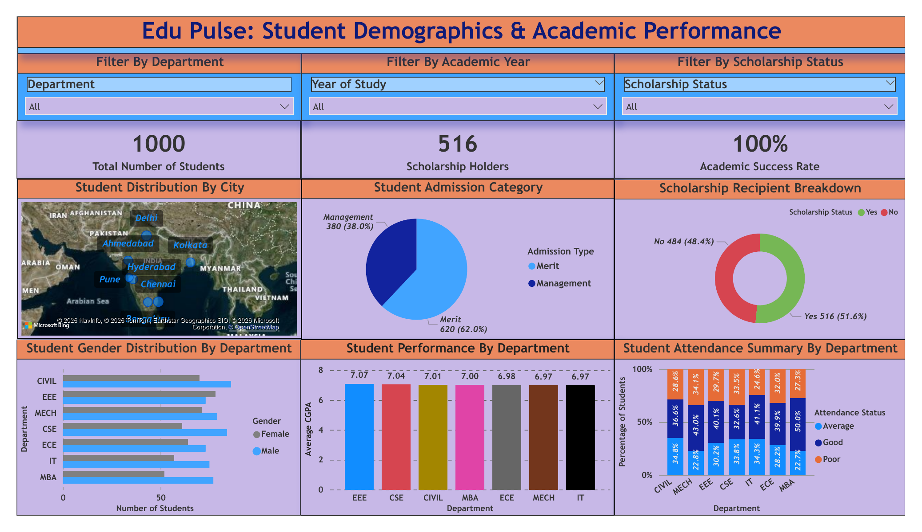
Figure 1: Dashboard 1 - Edu Pulse: Student Demographics & Academic Performance
Dashboard 2: Edu Pulse: Student Engagement and Campus Placement Outcomes
This dashboard analyzes student extracurricular immersion across campus clubs, career recruitment conversion rates, corporate compensation benchmarks (Mean and Maximum LPA), recruiter hiring shares, and internship-to-placement pipeline efficacy.
- Top Slicers: Department (Filter By Department), Year of Study (Filter By Academic Year), Scholarship Status (Filter By Scholarship Status).
- Executive KPI Cards: Career Placement Achievement (165 Placed / 269 Eligible - 61.3% Conversion), Average Salary Package (10.31 LPA), Highest Salary Package (17.64 LPA).
- Core Visuals Included: Student Club Participation Analysis (Treemap - E-Cell 758, Coding Club 756, Sports Club 754, Robotics Club 748, NSS 736), Campus Placement Achievement (Gauge Visual - 61.3% against target), Company-Wise Placement & Package Summary (Matrix - Average LPA, Maximum LPA, and Headcount Hired across Accenture, Amazon, Cognizant, Deloitte, Google, IBM, Infosys), Internship Domain vs. Placement Outcome (Clustered Column Chart - Placed vs. Not Placed conversion across Software, Data Analytics, Core Engineering, Management, and Cybersecurity).
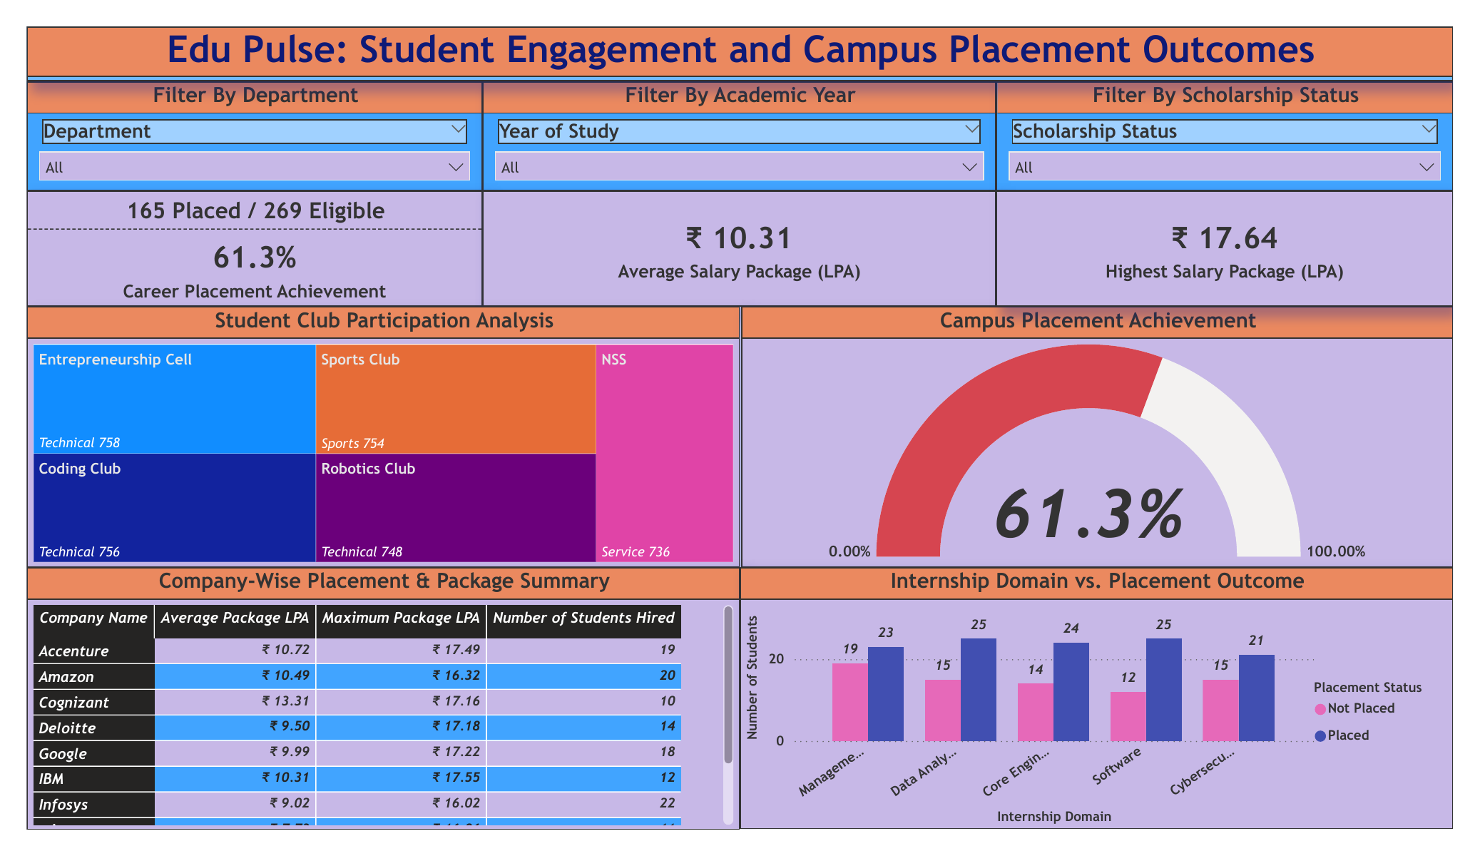
Figure 2: Dashboard 2 - Edu Pulse: Student Engagement and Campus Placement Outcomes
7. Institutional Insights & Strategic Recommendations
Synthesizing the empirical observations across Dashboard 1 (Demographics & Academics) and Dashboard 2 (Engagement & Career Outcomes) yields four strategic pillars for institutional intervention:
1. Department-Specific Attendance Intervention & Retention Protocols
Observation: The 100% Stacked Column Chart in Dashboard 1 reveals critical variations in attendance stability across departments. Mechanical (34.1%), CSE (33.5%), and Civil (28.6%) display significant cohorts categorized as 'Poor' (<70% attendance), whereas overall academic success remains at 100% with average CGPA tightly clustered between 6.97 (IT/MECH) and 7.07 (EEE).
Strategic Actions:
• Automated Early-Alert ERP Triggers: Deploy bi-weekly automated notifications to academic mentors and parents whenever a student's attendance drops below 75%, prior to midterm evaluation cycles.
• Root-Cause Attendance Audits in Core Engineering: Conduct qualitative surveys in MECH, CIVIL, and CSE to evaluate whether laboratory scheduling overlaps, transit constraints, or lecture delivery pacing contribute to the higher absentee rate.
2. High-Yield Internship Curriculum Alignment & Practical Skill Incubation
Observation: Dashboard 2 demonstrates that internship domain selection strongly dictates full-time recruitment success. Students completing internships in Software (25 Placed vs. 12 Unplaced - 67.6% conversion), Data Analytics (25 Placed vs. 15 Unplaced - 62.5% conversion), and Core Engineering (24 Placed vs. 14 Unplaced - 63.2% conversion) significantly outperform Management internships (23 Placed vs. 19 Unplaced - 54.8% conversion).
Strategic Actions:
• Pre-Final Year Technical Skill Bootcamps: Introduce institutional micro-credentials in Full-Stack Development, Cloud Architecture, and Applied Data Science during semesters 5 and 6 to elevate internship clearance rates.
• Corporate Mentorship for Management & Cyber Domains: Strengthen corporate tie-ups in Cybersecurity and Management consulting to bridge the conversion gap and ensure students receive interview training tailored to corporate hiring rubrics.
3. Corporate Recruiter Diversification & High-Tier Compensation Expansion
Observation: The placement conversion rate stands at 61.3% (165 Placed out of 269 Eligible Candidates), with an Average Package of 10.31 LPA and a peak offer of 17.64 LPA. However, the Company-Wise Placement Matrix indicates recruitment concentration among mass and tier-1 IT recruiters (Infosys: 22 hires, Amazon: 20 hires, Accenture: 19 hires, Google: 18 hires, Deloitte: 14 hires, IBM: 12 hires, Cognizant: 10 hires). Notably, Cognizant leads average compensation at 13.31 LPA, while Infosys averages 9.02 LPA.
Strategic Actions:
• Mid-Tier Corporate Outreach Drive: Target mid-market product enterprises and specialized engineering firms to absorb the remaining 38.7% (104 students) unplaced eligible cohort.
• Premium Package Incubation Tracks: Establish targeted interview preparation for super-dream recruiters (>15 LPA) to raise the average package benchmark across core non-computing engineering disciplines.
4. Extracurricular Engagement Capitalization & Holistic Profiling
Observation: Student engagement is vibrant across both technical and non-technical clubs, led by Entrepreneurship Cell (758 active students), Coding Club (756), Sports Club (754), Robotics Club (748), and National Service Scheme (NSS - 736). Active participation across technical and leadership clubs directly supplements resume competitiveness during corporate placement shortlisting.
Strategic Actions:
• Hackathon & Project Hack Days: Direct joint funding from E-Cell, Coding Club, and Robotics Club to sponsor capstone project incubations, providing students with tangible GitHub portfolios to present during technical placement interviews.
• Holistic Activity Credits: Institutionalize activity points linked to club participation to incentivize consistent campus engagement and foster well-rounded graduates.

